Geometry Unit For Grades 5 and 6

Julie Cook - Century Middle School, Park Rapids, MN
jcook2@parkrapids.k12.mn.us

Gabe Sturtz - Century Middle School, Park Rapids, MN
gsturtz@parkrapids.k12.mn.us

Alison Tisdell – Northern Elementary, Bemidji MN
Alison_tisdell@isd31.net

Amy Zimmerman – St. Philips, Bemidji MN
azimmermann@stphilipsbemidji.org

Executive Summary:
Unit Goal: Students will work with a variety of manipulatives and in a number of situations to practice, explore, and understand many different examples of geometry. Students will be introduced to various geometric terms and will be able to apply them to their everyday lives. Students will start to build a broader knowledge of the importance of understanding why geometry is important. They will do this by completing tasks that allow them the chance to apply shapes, area, perimeter and other geometric terms to their real life. They will also explore the metric system within this unit. Some of the lessons included in this unit will take different amounts of time, or would be better used as interventions rather than whole group activities. It is all dependent upon the level of your students.
Teaching Strategies: Students will work as individuals, in small groups and as a whole class to discover and explore how geometry can be used in the world around us.

Minnesota Standards:
Describe, classify, and draw representations of three-dimensional figures. 5.3.1.1 Describe and classify three-dimensional figures including cubes, prisms and pyramids by the number of edges, faces or vertices as well as the types of faces. 5.3.1.2 Recognize and draw a net for a three-dimensional figure.

Determine the area of triangles and quadrilaterals; determine the surface area and volume of rectangular prisms in various contexts.
▲5.3.2.1 Develop and use formulas to determine the area of triangles, parallelograms and figures that can be decomposed into triangles.
▲5.3.2.2 Use various tools and strategies to measure the volume and surface area of objects that are shaped like rectangular prisms.
←5.3.2.3 Understand that the volume of a three-dimensional figure can be found by counting the total number of same-sized cubic units that fill a shape without gaps or overlaps. Use cubic units to label volume measurements.
▲5.3.2.4 Develop and use the formulas V = ℓwh and V = Bh to determine the volume of rectangular prisms. Justify why base area B and height h are multiplied to find the volume of a rectangular prism by breaking the prism into layers of unit cubes.

Calculate perimeter, area, surface area and volume of two- and three-dimensional figures to solve real-world and mathematical problems.
▲6.3.1.1 Calculate the surface area and volume of prisms and use appropriate units, such as cm2 and cm3. Justify the formulas used. Justification may involve decomposition, nets or other models.
6.3.1.2 Calculate the area of quadrilaterals. Quadrilaterals include squares, rectangles, rhombuses, parallelograms, trapezoids and kites. When formulas are used, be able to explain why they are valid.
▲6.3.1.3 Estimate the perimeter and area of irregular figures on a grid when they cannot be decomposed into common figures and use correct units, such as cm and cm2

Choose appropriate units of measurement and use ratios to convert within measurement systems to solve real-world and mathematical problems.
6.3.3.1 Solve problems in various contexts involving conversion of weights, capacities, geometric measurements and times within measurement systems using appropriate units.
6.3.3.2 Estimate weights, capacities and geometric measurements using benchmarks in measurement systems with appropriate units.

NCTM Standards:
Grades 3–5 Expectations: In grades 3–5 each and every student should–
- identify, compare, and analyze attributes of two- and three-dimensional shapes and develop vocabulary to describe the attributes;
- classify two- and three-dimensional shapes according to their properties and develop definitions of classes of shapes such as triangles and pyramids;
- investigate, describe, and reason about the results of subdividing, combining, and transforming shapes;
- explore congruence and similarity;
- make and test conjectures about geometric properties and relationships and develop logical arguments to justify conclusions.
Grades 6–8 Expectations: In grades 6–8 each and every student should–
- precisely describe, classify, and understand relationships among types of two- and three-dimensional objects using their defining properties;
- understand relationships among the angles, side lengths, perimeters, areas, and volumes of similar objects;
- create and critique inductive and deductive arguments concerning geometric ideas and relationships, such as congruence, similarity, and the Pythagorean relationship.
Grades 3–5 Expectations: In grades 3–5 each and every student should–
- describe location and movement using common language and geometric vocabulary;
- make and use coordinate systems to specify locations and to describe paths;
- find the distance between points along horizontal and vertical lines of a coordinate system.
Grades 6–8 Expectations: In grades 6–8 each and every student should–
- use coordinate geometry to represent and examine the properties of geometric shapes;
- use coordinate geometry to examine special geometric shapes, such as regular polygons or those with pairs of parallel or perpendicular sides.
Grades 3–5 Expectations: In grades 3–5 each and every student should–
- build and draw geometric objects;
- create and describe mental images of objects, patterns, and paths;
- identify and build a three-dimensional object from two-dimensional representations of that object;
- identify and draw a two-dimensional representation of a three-dimensional object;
- use geometric models to solve problems in other areas of mathematics, such as number and measurement;
- recognize geometric ideas and relationships and apply them to other disciplines and to problems that arise in the classroom or in everyday life.
Grades 6–8 Expectations: In grades 6–8 each and every student should–
- draw geometric objects with specified properties, such as side lengths or angle measures;
- use two-dimensional representations of three-dimensional objects to visualize and solve problems such as those involving surface area and volume;
- use visual tools such as networks to represent and solve problems;
- use geometric models to represent and explain numerical and algebraic relationships;
- recognize and apply geometric ideas and relationships in areas outside the mathematics classroom, such as art, science, and everyday life.

Table of Contents
Pre-test and posttest will be the same test. Pretest will be given at the beginning of the unit and the posttest will be given to wrap up the unit.

Day 1- Digital Shapes Scavenger Hunt (Day 1)
Day 2- Digital Shapes Scavenger Hunt (Day 2)
Day 3- Spoons Game: Area of Rectangles and Squares
Day 4- Spoons Game: Volume of Rectangular Prisms
Day 5- Metric Olympics (Day 1)
Day 6- Metric Olympics (Day 2)
Day 7- Perimeter and Area Robot (Day 1)
Day 8- Perimeter and Area Robot (Day 2)
Day 9- Christmas Geometry Project (Day 1)
Day 10- Christmas Geometry Project (Day 2)
Day 11- Christmas Geometry Project (Day 3)
Day 12- The City of Shapes
Day 13- The City of Shapes Cont.
Day 14- Geometry U-Know It
Day 15- Area Dominoes
Day 16- Introducing characteristics of a 3 Dimensional Shape
Day 17-Review Vertex, Face, Edge, and Introduce 3D Shape Names
Day 18- Introduce 3D Nets
Day 19-Angry Birds 3D Nets
Day 20- Review Nets, Area, and Introduce Surface Area

Name: _____________________________________________________ Date: ___________
Geometry Pre-Test

1. What metric unit of measure would you use to measure the weight of a car? | 2. What metric unit of measure would you use to measure the volume of a paint can? | 3. What metric unit of measure would you use to measure the mass of a dog?
4. What metric unit of measure would you use to measure the height of your pencil? | 5. What metric unit of measure would you use to measure the distance from your house to school? | 6. What is the formula for finding area of a rectangle?
7. How do you find the perimeter of a shape? | 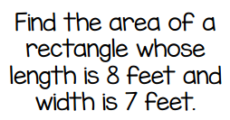  8.  11. | 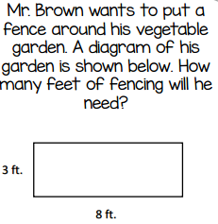  9.
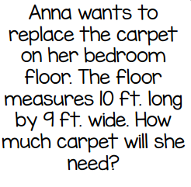  10. | 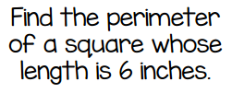 | 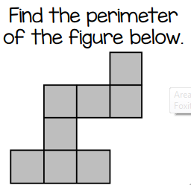  12.
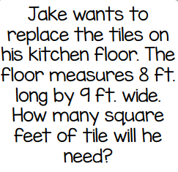  13. | 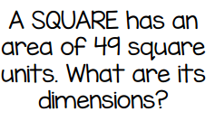  14. | 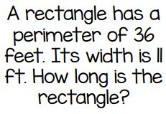  15.
16. What type of figure can be formed by folding this net?  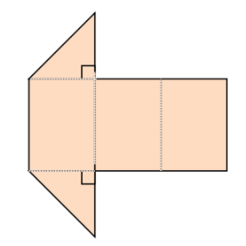 | 17. What type of figure can be formed by folding this net?  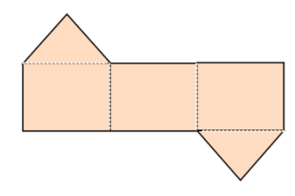 | 18. What type of figure can be formed by folding this net?  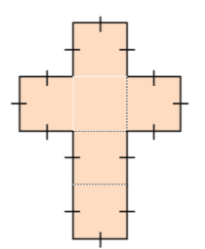
19. Find the volume of the prism.  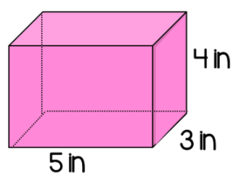 | 20. Find the volume of the prism.  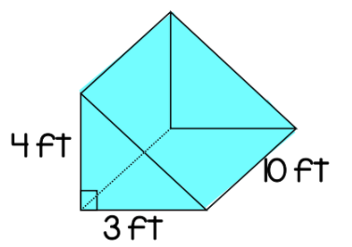 | 21.  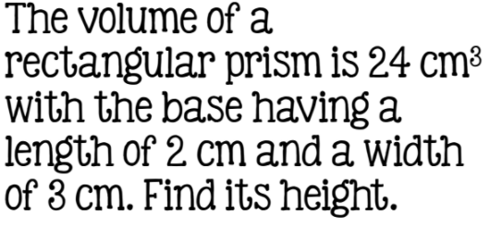
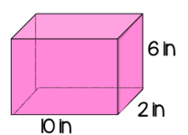  22. Find the surface area of the prism. | 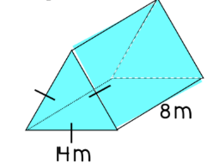  23. Find the surface area of the prism. | 24. Find the surface area of the prism whose base is 6 feet by 4 feet, and is 10 feet high.

Activity 1 - Digital Shapes Scavenger Hunt
https://www.teacherspayteachers.com/Product/Shape-Search-2514072
Launch:
Day 1: Read one or more of the following books:
Shape Up!: Fun With Triangles and Other Polygons by David A. Adler (1998)
If You Were a Quadrilateral (Math Fun) by Molly Blaisdell (2009)
The Greedy Triangle (Scholastic Bookshelf) by Marilyn Burns (2008)
If You Were a Polygon (Math Fun) by Marcie Aboff (2009)
Explore:
Day 1: Students will break into pairs to complete the digital scavenger hunt. Students will be given a handout like the one below to complete. Students will need a device that can take pictures (iPad, Chromebook, etc.). Students can go around the school to find examples of each shape. If students find more than one example of each shape, they can take pictures of each of them to include in their final project.
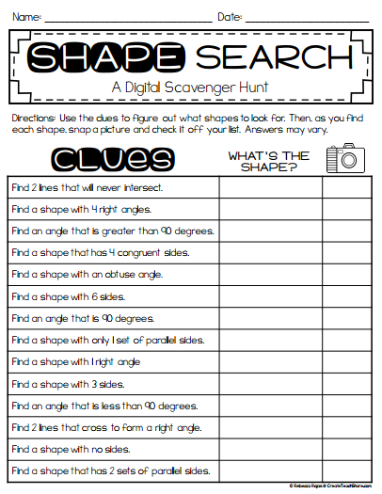
Day 2: After students have finished their worksheet they will need to compile the pictures they took into a GoogleDoc (or other program) that they have shared with their partner and the teacher. Students should label each page with the clue they were given and then put in the pictures they took. They should also include the shape name and finally they should write a few key ideas about the shape. Here is an example of what they could do:
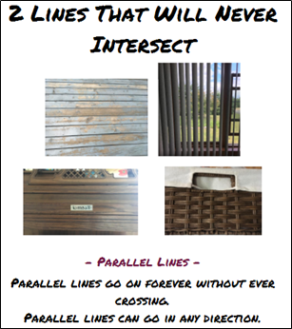
Share:
Students will share their Google Doc with the class. As a large group students can discuss what they like about each category. If needed students can fix any shapes may have done incorrectly.
Summarize:
Together the class can make one large GoogleDoc to print out and use as reference in class.

Activity 2 - Spoons Game: Area of Rectangles and Squares
Launch:
Discuss whether any of the students have played the game of spoons before. Talk about how it’s played and go over any questions students may have. This version of Spoons is a little different than the card game, the student without a spoon is not eliminated from the game, rather they must make the winner prove that they got 4 matching cards and then they get a letter on their scoreboard.
Briefly review how to find the area of rectangles and squares. Answer any questions that students may have before they start the game.
Explore:
Students will need to be in groups of 4. Each group will need a copy of the game pieces and 3 spoons. Students will sit in a circle with the 3 spoons in the middle. One student acts as the dealer (the dealer should be a different student each game.) The dealer shuffles the cards and deals out 4 to each student. The dealer then starts the game by picking up a card and deciding whether to keep it or discard it. If they discard it, they pass it to the player on the left. If they choose to keep it they must pick a different card to discard and pass to the player on the left. Each person in the group takes turns passing one card that they do not want to the player to the left. When a player has 4 cards that are the same, he/she, as quietly as possible, takes a spoon from the center. When a spoon is taken, the other players must take a spoon until there is one player without a spoon. The player without the spoon must say, “Prove It!” to the player that has the match. The player with the match has to prove that his/her cards are matches. If the player is able to prove it, the player without the spoon has to add an S to his/her scoreboard. If the original winner cannot prove that his/her cards match, they get the S on their scoreboard. When that rounds is done, gather up all the cards, pass to the new dealer, shuffle, and play again. The game ends when one player spells the word SPOONS on their scoreboard.
This game deals with reviewing the area of rectangles and squares. There are two sets of cards. The first set is a basic set and the second set is a more advanced set. Students can/should switch their card sets after they feel comfortable with the basic set of questions.
After the students have played this game for about 25-30 minutes have the students work together in their group to come up with their own set of Spoon cards for finding the area of rectangles and squares.
Share:
After students have played for a while and have used both sets of cards bring the students together for a large group discussion. Students can talk about whether or not they have method/plan for what they were doing and whether that was successful or not. Go over the answers to the cards and discuss methods students used to solve each problem.
Have students share one matching set of their Spoons game and discuss it as a large group. Does it work? Would it go into a basic set or a challenging set? Anything that the group should change?
Summarize:
Go over any questions the students found to be more difficult and discuss what could be done to extend the game. Clear up any misconceptions students had as they played the game.

Activity 3 - Spoons Game: Volume of Rectangular Prisms
Launch:
Today the students will be playing another round of the game of Spoons. Remind students how it’s played and go over any questions students may have. This version of Spoons is a little different than the card game, the student without a spoon is not eliminated from the game, rather they must make the winner prove that they got 4 matching cards and then they get a letter on their scoreboard.
Briefly review how to find volume of rectangular prisms. Answer any questions that students may have before they start the game.
Explore:
Students will need to be in groups of 4. Each group will need a copy of the game pieces and 3 spoons. Students will sit in a circle with the 3 spoons in the middle. One student acts as the dealer (the dealer should be a different student each game.) The dealer shuffles the cards and deals out 4 to each student. The dealer then starts the game by picking up a card and deciding whether to keep it or discard it. If they discard it, they pass it to the player on the left. If they choose to keep it they must pick a different card to discard and pass to the player on the left. Each person in the group takes turns passing one card that they do not want to the player to the left. When a player has 4 cards that are the same, he/she, as quietly as possible, takes a spoon from the center. When a spoon is taken, the other players must take a spoon until there is one player without a spoon. The player without the spoon must say, “Prove It!” to the player that has the match. The player with the match has to prove that his/her cards are matches. If the player is able to prove it, the player without the spoon has to add an S to his/her scoreboard. If the original winner cannot prove that his/her cards match, they get the S on their scoreboard. When that rounds is done, gather up all the cards, pass to the new dealer, shuffle, and play again. The game ends when one player spells the word SPOONS on their scoreboard.
This game deals with reviewing the volume of rectangular prisms. There are two sets of cards. The first set is a basic set and the second set is a more advanced set. Students can/should switch their card sets after they feel comfortable with the basic set of questions.
After the students have played this game for about 25-30 minutes have the students work together in their group to come up with their own set of Spoon cards for finding the volume of rectangular prisms.
Share:
After students have played for a while and have used both sets of cards bring the students together for a large group discussion. Students can talk about whether or not they have method/plan for what they were doing and whether that was successful or not. Go over the answers to the cards and discuss methods students used to solve each problem.
Have students share one matching set of their Spoons game and discuss it as a large group. Does it work? Would it go into a basic set or a challenging set? Anything that the group should change?
Summarize:
Go over any questions the students found to be more difficult and discuss what could be done to extend the game. Clear up any misconceptions students had as they played the game.

Activity 4 - Metric Olympics
Launch:
Watch a video introducing the metric system: https://youtu.be/djTNUp4XIRo
Discuss with the students that there is another system of measurement outside of what we use in the United States called the metric system.
Explore 1:
Share and discuss the most commonly used metric units using the following posters:
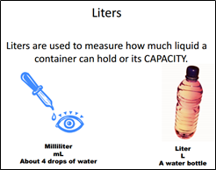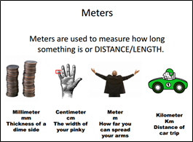
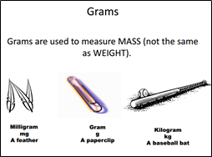
Using the following response sheet students should work in their groups and decide what is the best unit of measure for the task cards. (One example provided. They can be found at https://www.teacherspayteachers.com/Product/Choose-the-Best-Metric-Measurement-Task-Cards-247810)
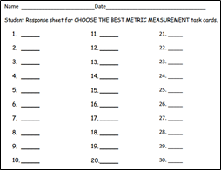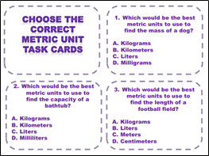
Share 1:
After time has been given to complete the task cards discuss as a large group the answers to each and go over any questions.
Explore 2: - this will take more than one day to complete. Start on day one
and finish whatever is left on day 2.
The next activity is to compete in the Metric Olympics. Students should work in their group to create a team flag using the template provided.
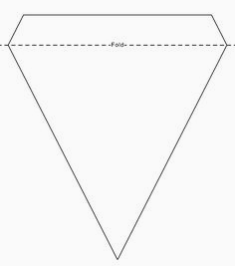
All students will participate in all events. The person with the smallest difference per event will be the group member whose score gets recorded by the teacher. Working in their groups of three, students will each make their estimates while sitting in the classroom. These estimates MUST be written in a green marker that you have borrowed and then returned to the teacher. When every group has completed their estimates the games may begin.
Cards are set up throughout the classroom/pod describing the event for the students. Each student from each group will compete each event. Students need to write the actual measurement in the “Actual” column and then determine the difference between their estimate and actual measurements. Report the lowest score within your group to your teacher after each event. Wait until the call is made to switch events.
The team with the lowest overall score (from all classes) will be declared the winner and their team flag will be hung above all the others with second and third place hung in place with them. Awards are optional if teachers want to give them to the winner of each event.
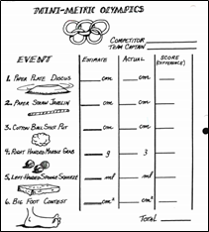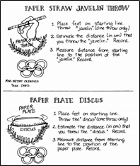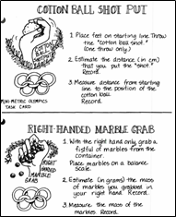
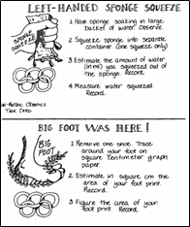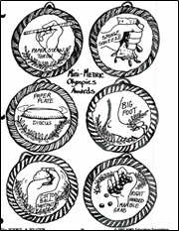

Share:
As a large group discuss how students used their knowledge of the terms to make their estimates. Did everyone do as well as they thought they would? Were there any surprises? Any event turn out differently than expected?
Summarize:
Review the measurements and their units from the beginning and answer any questions students may have of the metric system.

Perimeter and Area Robot
Day 1
https://www.teacherspayteachers.com/Product/Area-and-Perimeter-Robot-
Differentiated-72786
Standards:
Launch:
Share the NASA note to introduce the perimeter and area robot project. Here is the note:
“Greetings, You have been selected for a TOP SECRET mission from NASA to create a robot that will land on the moon. You will design a robot that will send the United States very import information. It is extremely important that you submit your best work. The robot must have certain measurements of perimeter and area for it to survive on the moon. Use grid pater to create your robot. You will cut out the grid paper and glue it to a large piece of construction paper to create your robot. Remember – the measurements must be EXACT!
NASA Design Team”
Explore:
Students will review the specific measurements for their robot. Provide grid paper so students can create their robots. Remind students to be creative as they create their robot.
Before students glue their robot to construction paper, they should have a classmate check over their work. This will ensure that they are meeting the design specifics for NASA.
Share:
Students will share their progress with a small group. They will share one challenge and one success of designing their robot according to the specifications. They will offer advice to each other to help them finish their robot the next class time.
Summarize:
Students will be challenged to remember the difference between area and perimeter. This will also reinforce the difference between area and perimeter. Students will also be given an area need to figure out dimensions which is different than what they have been exploring previously.

Perimeter and Area Robot
Day 2
https://www.teacherspayteachers.com/Product/Area-and-Perimeter-Robot-
Differentiated-72786
Standards:
Launch:
NASA called and is looking forward to seeing your designs. We will continue working on our robots.
Explore:
Students will review the specific measurements for their robot. Provide grid paper so students can create their robots. Remind students to be creative as they create their robot. Students should be close to finish.
Before students glue their robot to construction paper, they should have a classmate check over their work. This will ensure that they are meeting the design specifics for NASA.
Share:
Students will share their robot and the specifications with a different group from the previous day. They will tell their group the method they used to find their largest measurement. For example, if they needed an area of 169, students would describe how they found that area.
Summarize:
Students will be challenged to remember the difference between area and perimeter. This will also reinforce the difference between area and perimeter. Students will also practice describing their process to each other. Students will see different methods and strategies to reach the same area or perimeter.

Christmas Geometry Project
Day 1
https://www.teacherspayteachers.com/Product/Christmas-Geometry-Project-2244547?aref=d65xet6y
Standards:
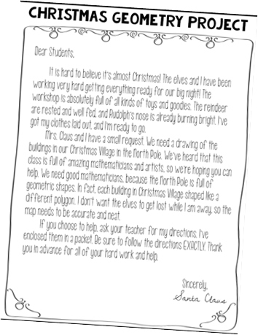
Launch:
Santa needs help creating a map for the North Pole so the elves know where to go while he is gone delivering presents. Santa left a letter and a set of directions on how to create the map of the North Pole. Each building will be a different polygon. This will be a multistep process starting with the rough draft.
Explore:
Review the letter from Santa with the students and the directions for the map. Students will work with partners to work through the directions to create a rough draft. Santa’s directions have students bringing their rough draft for the teacher to review with them.
Share:
When students complete their rough draft, they will write in their journal describing their process to create their map. They will reflect on the successes and challenges.
Students will also share their progress with the teacher. This will determine if more time is needed to work on the rough draft or if they are ready for the next step.
Summarize:
Students will use their knowledge of the different polygons including different quadrilaterals. This knowledge will help them design the map for the North Pole.
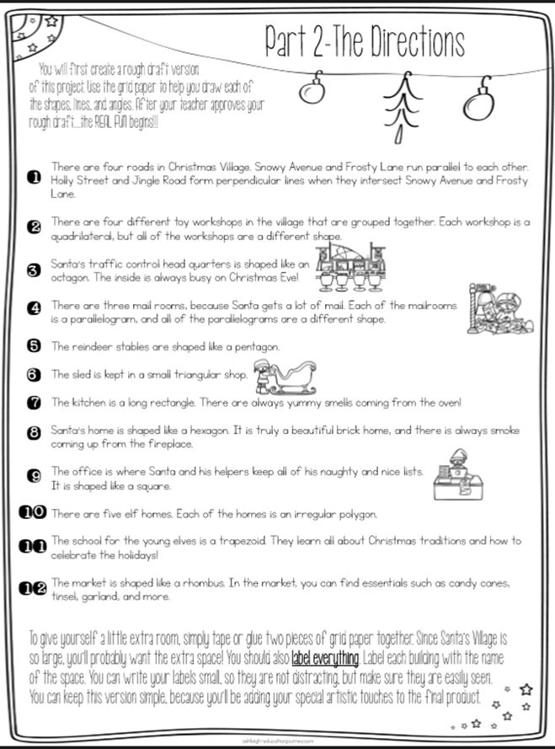
Christmas Geometry Project
Day 2
https://www.teacherspayteachers.com/Product/Christmas-Geometry-Project-2244547?aref=d65xet6y
Standards:
Launch:
Previously, we looked at Santa’s letter that asked for our help in creating a map for the North Pole so the elves know where to go while he is gone delivering presents. Santa left a set of directions on how to create the map of the North Pole. Each building will be a different polygon.
Explore:
Students were working with partners to create their rough draft. Those who have finished will advance to the next step which involves being creative with their map. They will trace all their buildings with markers and create road signs, traffic lights, and sidewalks. They will make the North Pole festive for Christmas. Santa included more directions for this part that outlines more things to include.
Share:
When they finished, they will continue to write about their map. They will describe any more successes and challenges in their map creation. Students will also write ideas on what they plan to say in their presentation to the class such as why they chose to put a specific building where they located it.
Summarize:
Students will use their knowledge of the different polygons including different quadrilaterals. This knowledge will help them design the map for the North Pole. Students will also use their creativity to create Santa’s village that is ready for the Christmas holiday.
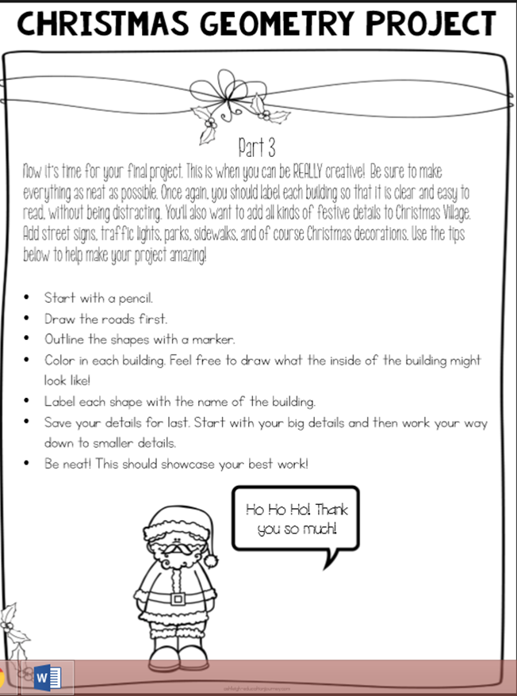
Christmas Geometry Project
Day 3
https://www.teacherspayteachers.com/Product/Christmas-Geometry-Project-2244547?aref=d65xet6y
Standards:
Launch:
Previously, we looked at Santa’s letter that asked for our help in creating a map for the North Pole so the elves know where to go while he is gone delivering presents. Today we will be presenting our maps to our classmates.
Explore:
Students were working with partners to create their maps. As part of the process students were journaling including thoughts about what they would say for their presentation. The goal of these presentations is to have students use their math vocabulary to explain why they placed buildings where they did and how they created the roads.
Student maps will also be hung up on the wall for classmates to view up close when time allows.
Share:
Students will be presenting in front of the class and hanging their maps on the wall. Students will also share their journals with the teacher to help with teacher reflection on the activity.
Summarize:
Students will use their knowledge of the different polygons including different quadrilaterals. This knowledge will help them design the map for the North Pole. Students will also use their creativity to create Santa’s village that is ready for the Christmas holiday. Students will also use their math vocabulary to explain their thought process in creating their maps.

Activity 12: The City Of Shapes
https://www.teacherspayteachers.com/Product/Perimeter-and-Area-Project-1833278
Launch:
Start out this lesson by asking students if they have ever dreamt of becoming a city planner or architect. Tell them they are going to embark on a journey that is going to allow them the opportunity to become a city planner. They are going to create their own city of shapes. All they need is some graph paper, a pencil, and the brilliant brain in your noggin and you will be ready to create your very own city of dreams.
** This lesson is going to take multiple days to complete so the explore part of the lesson will get quite lengthy.
Explore:
Day 1: Students will start out by creating a city name, slogan, and population. After they have gotten creative with these things they will start to figure out the area and perimeter of certain “buildings” that are listed in their chart. Students will find area and perimeter for the following building by using the formulas along with drawing them out on graph paper to show how the formulas relate to the area and perimeter.
Day 2: Students will get new sheets of graph paper today so they can create their police station, fire station, and hospital. Students are given a list of items that each building needs to have placed in them. They are also given the dimensions of these items. They need to make sure that they place the items in spots so that all 5 items fit in the buildings without overlapping. Students need to make sure that they label all of their items. Once they have drawn out all of their items and buildings they need to fill in the graphs and charts to find the area and perimeter of each one.
Day 3: For the third day of this project students will be able to make a choice. They can choose to either create a block of houses or a room of their own. If they choose to create a block of houses they will have specific directions to follow such as:
· Each lot (rectangular space that includes a house and yard) where your houses are built should be 6,000 square feet. This is equal to 6 square units on your graph paper.
· Each rectangular lot must be separated from the next lot by at least one row of square units.
· You must fit at least 10 lots into the space, and they all must be the same shape and size. They should be in a straight row.
If students choose to design a room of their own they will have to have the following things present:
· Decide what shape your room will be.
· Your room must have a bed, dresser, bookshelf, and desk. You must find the area and perimeter of each of these items as well as the area and perimeter of your whole room.
· You can add anything else you want to your room as long as it fits and does not overlap any other item.
Share:
After we have completed each day students will hang their work around the classroom for their peers to look at. We will do gallery walks so students can ask each other questions and also see if they would make any changes to their buildings. Students will be encouraged to hold conversations with at least 3 other classmates about how they created their city and why they put their buildings where they did. Students will also be able to compare their measurements with their peers. If they have different areas and perimeters they know that they need to check their work.
Summarize:
The goal for these 3 lessons was to get students to think about using area and perimeter to help them create the most effective places to put items in a city, building, and room. This will give students an understanding of how they can arrange their room to get the most use of the area they have.

Activity 13: Geometry U-Know It
https://www.teacherspayteachers.com/Product/Geometry-Game-for-Math-Centers-Stations-2D-3D-Shapes-Translations-MORE-1004505
Launch:
Begin this lesson by making a list of geometry words that have been covered so far throughout the geometry unit. Have a deck of UNO cards out as well. Ask students who has ever played the card game Uno. Talk about the rules of the regular Uno games. Then tell students today we are going to play a game similar to Uno that called Geometry U-Know It!
Explore:
Give students the deck of U-Know It Cards. Tell them the following instructions:
· Shuffle the cards and then deal out five cards to each person, starting with the person to your left.
· Put the deck in the middle, and flip one card over.
· The person to the left of the dealer goes first. He/She may lay the same color, number, or type of card, he/she may also play a “wild” card.
· If the player has a playable card, he/she may lay it on the top of the discard pile in the middle. He/she must read the card and provide the correct response.
· If he/she is correct, play continues to the left (unless a reverse was used).
· If he/she is incorrect, they take back their card and draw two cards before play continues.
· If a player does not have a playable card in his/her hand, he/she may draw one card to try and get one. If he/she gets one, he/she may plat it. If not, play continues.
· If you run out of draw cards, take the discarded cards, shuffle, and reuse.
· Play continues until a player gets down to one card. He/she must yell, “U-Know!” before anyone else, or he/she must draw two cards.
· The first player to get rid of all of his/her cards WINS!
Share:
Once students are wrapping up their games you can start a class discussion on how well they think they game went. Have students answer questions like:
· What was easy about the game?
· What was hard about the game?
· Were there any term you did not understand during the game?
This will give you an idea of what terms still need to be covered during the rest of your unit.
Summarize:
Students will get a good review of the terms that go with the geometry unit and will also be able to state which terms they still need to work on. You as the teacher will be able to reassess where you are with your geometry unit and what terms and concepts need a little more help.

Activity 14: Area Dominoes
https://www.teacherspayteachers.com/Product/Geometry-Game-for-Math-Centers-Stations-2D-3D-Shapes-Translations-MORE-1004505
Launch:
Review finding the area of shapes with students but showing some of the dominoes up on the board. Have student’s help you walk through finding the area of the shapes. Tell students they will be playing a game today that helps them review their knowledge of area of shapes.
Explore:
Break students into groups of 2-4 per group.
These cards are similar to traditional dominoes, with shapes instead of numbers. These cards should work just as well when printed in black and white. The colors do not necessarily match up, and do not add to the game.
Areas used in this game are 8, 10, 12, 15, 16, 20, 24, 28 and 36.
HOW TO PLAY
Object: To be the first to run out of all of your dominoes.
Set up: Deal out domino cards;
7 cards each for 2 players
6 cards each for 3 players
5 cards each for 4 players
Gameplay:
Choose which player starts. To do this, players each choose a card from the deck. The player with the highest area on one side of their domino goes first. Play then proceeds clockwise.
Players match the areas of their dominoes to the ever-growing snake of domino cards. If a player cannot play a domino card, they must draw a new domino card. This new card can be played straight away if the domino cards allow, and play continues.
The winner is the first person to play all of their domino cards. If no one can play a domino card, and there are no more draw cards in the deck, the game ends. The winner is the player with the least number of cards in their hand. A draw is possible.
For extra challenge, have players add the total areas they have left in their hand. The player with the lowest total area wins.
Share:
Once students have played the game for some time and are even getting close to completion of it start asking some questions to broaden their thinking. You can have them leave their dominoes in the order they are and walk around to see if anybody got any different answers than what they did. This will allow them to have some discussion as to who is correct and if somebody made a mistake.
Summarize:
The goal of the game today is to get students thinking about the area of a shape and how to figure it out. They should be able to solve area problems fluidly by the time they have finished with this game.

Name of Lesson: Introducing characteristics of a 3 Dimensional Shape

Objective: 5.3.1.1 Describe and classify three-dimensional figures including cubes, prisms and pyramids by the number of edges, faces or vertices as well as the types of faces.

Items Needed: Venn Diagrams for groups, 3D shapes for groups, construction paper for student notes, markers
- Launch: Start with a discussion about 2D shapes (this should be a review of past lessons). Go through how to classify 2D shapes and how they are similar and different. After going through squares, rectangles, triangles, etc. Bring out a cube.

- Explore: Have students brainstorm all they know about 3 dimensional shapes in pairs/groups of 3. Hand out cubes to all groups for them to physically observe these shapes along with a Venn Diagram. Groups should write down all the similarities and differences they can notice. As groups are working start giving out pyramids.

- Share: Have students share their lists by sharing one thing their group came up with up on a whole group VD on the SmartBoard.

- Summarize: Have students create the page of notes which includes: faces, edges, and vertices.
Face:
Edge:
Vertex:
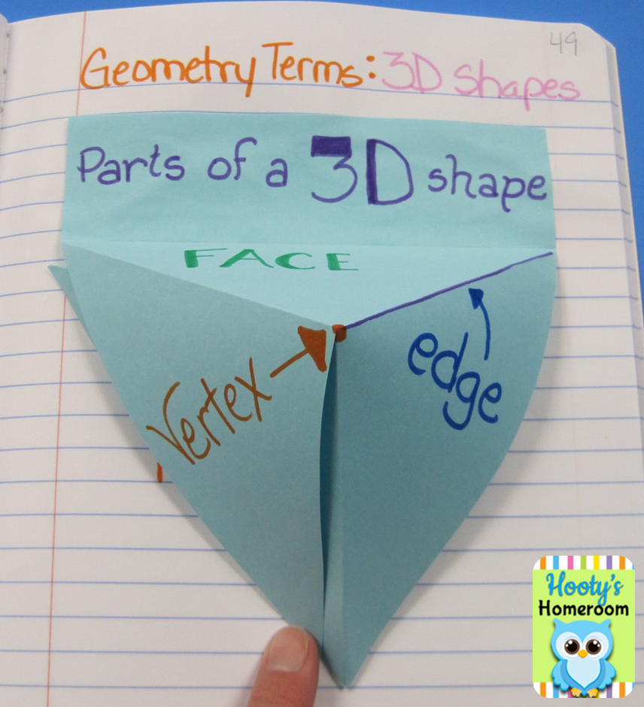

Name of Lesson: Review Vertex, Face, Edge, and Introduce 3D Shape Names

Objective: 5.3.1.2 Recognize and draw a net for a three-dimensional figure.

Items Needed: 3D Shapes: Cube, Rectangular Prism, Square Pyramid, Rectangular Pyramid, WS with table of Shape Vs. vertices, faces, and edges, images of nets

- Launch: Have students take out their notes from yesterday. Have students discuss the definition of the 3 terms covered the day before.

- Explore: Give each group one 3D shape, have them talk through the vertices, faces, and edges of the shape. Have groups trade shapes so each group can talk through the 3 characteristics of each shape and fill out how many each shape has on their own individual chart you give them.

- Share: Students will be assigned a 3D shape to share their findings and explain how they got the numbers they got. Students will stay in small group and join 3 other small groups, so the larger groups can share their findings for their chart.

- Summarize: After sharing and completing the complete chart, students will be presented with their net. Teacher will explain the function of a net and use the cube net to create a cube. Students will be given 5 different diagrams of nets and will be asked to come back tomorrow with a guess to which shape goes with each net.

 | Faces | Edges | Vertices
Cube
Rectangular Prism
Square Pyramid
Rectangular Pyramid

Name of Lesson: 3D Shape Nets

Objective: 5.3.1.2 Recognize and draw a net for a three-dimensional figure.

Items Needed: 3D Shapes: Cube, Rectangular Prism, Square Pyramid, Rectangular Pyramid, WS with nets

- Launch: Have students take out their tables from yesterday. Have students discuss the definition of the 3 terms covered the day before. In groups of 3 or 4, give each group a net for a certain shape.

- Explore: Have students cut out the shape and piece them together. After groups put together each shape, have them move on to the next one until they have all four of them created.

- Share: Have students share what 2D shapes create each 3D shape.

- Summarize: Have students fill out this chart to describe how many of each shape help create each 3D shape.

 | Square | Rectangle | Triangle
Cube
Rectangular Prism
Square Pyramid
Rectangular Pyramid

Name of Lesson: Angry Birds 3D Nets

Objective: 5.3.1.2 Recognize and draw a net for a three-dimensional figure.

Items Needed: Large grid paper for nets, scissors, large construction paper, glue

- Launch: Put up a net for a rectangular prism. Have students discuss in small groups what 3D shape this net will make and how they know it will make that shape.

- Explore: Students will work in groups of 4 to create four different 3D shapes: cube, rectangular prism, square pyramid and rectangular pyramid. Students can decide in their groups who will make which. Each student will get large grid paper to draw their net.

- Share: Students will share in their small groups the net they drew. All group members must agree the net that is drawn will create the correct 3D shape. Once students have agreed the net is correct, they will initial the grid paper on the inside of the net. Then, students will cut out their nets and trace their net on the large construction paper. Students can then cut out their construction paper to create their 3D shape.

- Summarize: Students will prove their understanding of the concept by creating their Angry Bird and turning in their net.
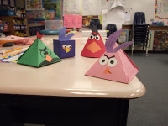

Name of Lesson: Review Nets, Area, and Introduce Surface Area

Objective: 5.3.2.2 Use various tools and strategies to measure the volume and surface area of objects that are shaped like rectangular prisms.

Items Needed: Grids students made from yesterday

- Launch: Have students discuss the shapes that went into creating their 3D shapes. Have students find in their notes they took on area of 2D shapes.

Tell them they need to figure out how much paint they would need if these birds were giant and each square unit of their bird took 1 quart of paint to paint it.

- Explore: Students will work individually to figure out how much paint they would need to paint each Angry Bird they created yesterday. Have students trade their bird nets from yesterday so they can calculate all different 3D shapes.

- Share: Students will share in their small groups the numbers they got for each surface area. From there, have the group choose 1 net to share with the whole group and how they calculated the surface area of their 3D shape.
Summarize: Go through all the different ways groups calculated their surface area of each figure.

